Online Meeting System Documentation(THN)

Overview (How Online Meetings Work)
Healar Network supports two meeting platforms:
- Google Meet (Primary)
- Zoom (Backup / Fallback)

Logic
- If Google Meet is connected & working → Google Meet link is created
- If Google Meet fails or is not connected → Zoom meeting link is created automatically
- Healar & User do NOT need Google or Zoom login
- Only Super Admin connects accounts once
Super Admin Responsibility (VERY IMPORTANT)
Using This email info@thehealernetwork.com to connect to Google Cloud Console
How to Create account Google Cloud Console
1: Create a project (https://console.cloud.google.com)
2: Enable Google Calendar API
3 :Create OAuth Client ID
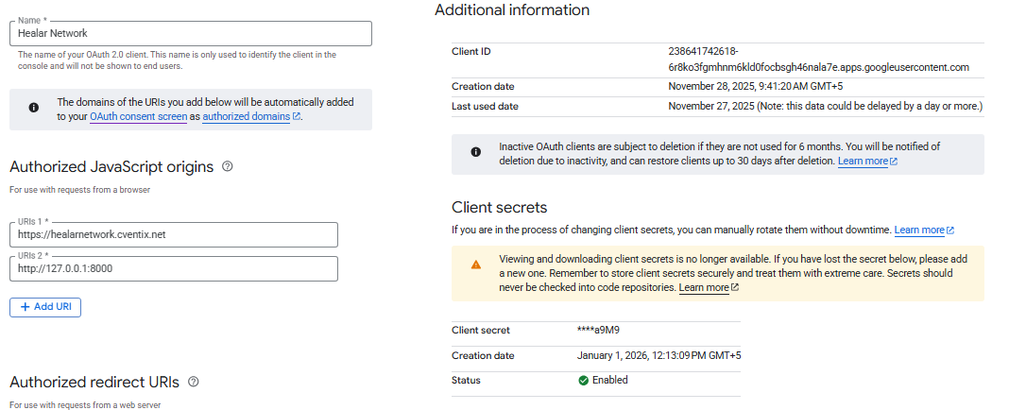
4 :Download credentials.json
The (credentials.json) file and (Client ID , Secret), send to (abdul Rehman)
How to connect Superadmin Dashboard to Google Cloud Console
https://healarnetwork.cventix.net/superadmin
Email:superadmin@gmail..com
pass:admin
In dashboard Go to link Google Meet page and connect to Google Clound Console
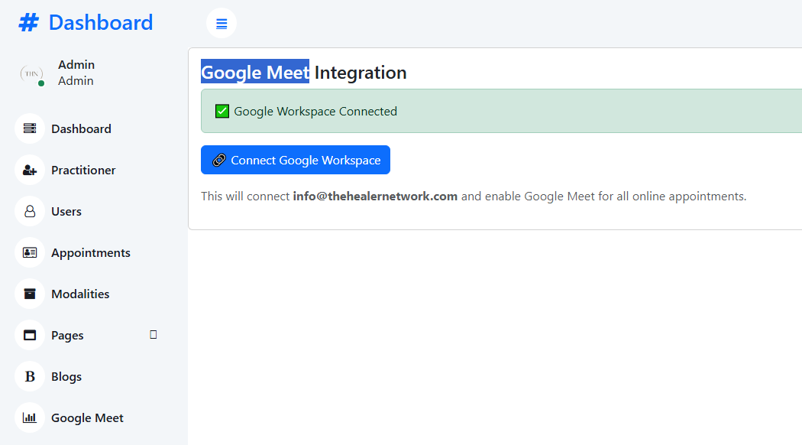
Store Super Admin Google Token (One Time) in Database
Since info@thehealernetwork.com is the Super Admin:
- Do OAuth once
- Store token securely
- Reuse for all meetings (This store on THN Database )

